**EN 001203 Computer Programming (Section 5)**

**Class website:** <https://sites.google.com/a/kku.ac.th/classes/cpg>

To learn problem-solving skills through computer programming.

**To do:**

* Download course slides. See class website (under class materials)

**Week 3 Session 2**

**Previously, we have discussed:**

* Orientation and introduction, basic computer system, basic software development paradigm, the tool we will use, some terminologies, basic system commands, class website and class materials.

This week objectives are:

* Hand on our first C++ program

* in a classic style

* with CodeBlocks

* Where to get reference on C++ language (beside Googling it, of course)

* Practice output programs

* Get to know Autolab

**2. Hand on our first C++ program**

**! Make sure that we have the compiler (GNU G++) and the IDE---CodeBlocks installed.**

**2.1. Compile and run in a classic style**

2.1.1. Write our first C++ program.

2.1.1.1. Use Notepad to write the following code.

#include <iostream>

int main(){

std::cout << "Hello, World++";

}

2.1.1.2. Save it as helloworld.cpp, as shown in the picture.

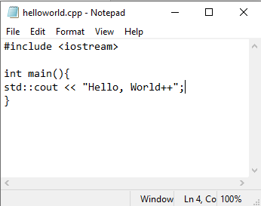

{ } Curly brackets are here, next to P button. You need <SHIFT>.

# (pound sign/sharp/hash tag) is here, on the 3 button. Press <SHIFT> + 3.

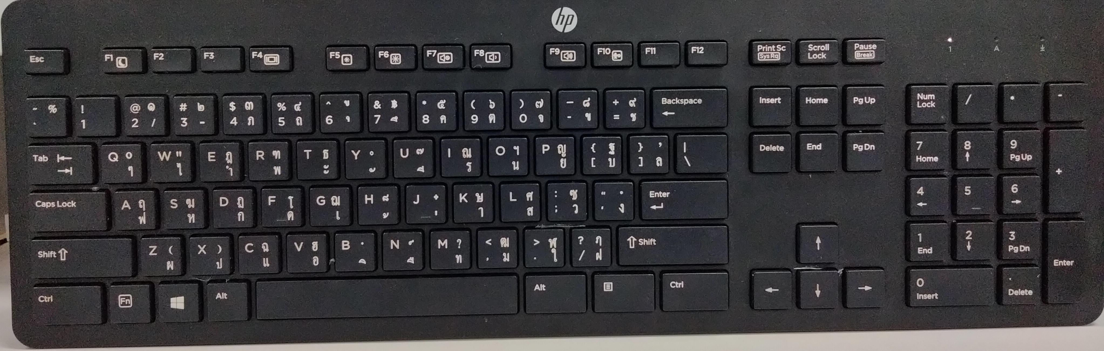

: (colon) and ; (semi-colon) are here, next to L. Press <SHIFT> to get colon.

2.1.2. Compile the program.  
At C:\GetPrep\cpp on the terminal, type

g++ helloworld.cpp -o helloworld.exe

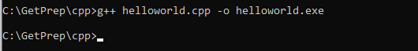

If it does not work, it may be either compiler is not installed or the path is not set properly.

2.1.3. Run the program.

It is like other regular executable files. Call its name to run it.

Type helloworld

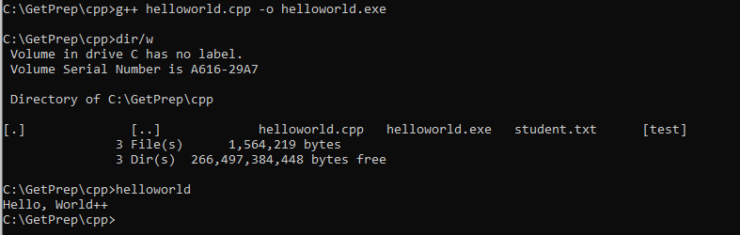

(4) See the program output.

(3) To run, call its name.

(2) After compilation, we get the executable file (machine code).

(1) This compiles helloworld.cpp to helloworld.exe.

Mission accomplished.

**2.2. Compile and run with CodeBlocks**

Dummy

Well Done!!!

**3. Recommended reference on C++ language**

To learn more about C++ language, including syntax, reserved words, available functions, libraries, and what libraries provide, check out

https://en.cppreference.com/w/

**Exercises**

E3.1. Which ones of the following terms are keywords in C++?

Terms to check: return, exit, char, character, false, fake, for, to, if, whether, int, integer, long, short, not, sizeof, weightof, switch, plug, true, real, float, sink, try, attempt, while, and when.

[Hint: check under keywords.]

E3.2. Which ones of the following terms are C++ Standard Library headers?

Terms to check: <cstdlib>, <cspecial>, <ctime>, <cplace>, <memory>, <climits>, <exception>, <outstanding>, <cstring>, <crope>, <array>, <cmath>, <cphysics>, <random>, <numbers>, <locale>, <iostream> and <cstdio>.

[Hint: check under headers.]

E3.3. Which ones of the following terms are functions in the standard library <cstring>?

Terms to check: strcpy, strcopy, strdog, strcat, strlen, and strcmp.

[Hint: see <cstring> under headers.]

4. Practice output programs

Good Job!!!

5. Get to know Autolab

5.1 Log in Autolab

Well Done!!!

5.2 Submit the answers

Mission accomplished.